

**UCL Space syntax and analytical design workshops II**

**Introduction to qgis**

**October 2017**

**Ioanna Kolovou**

**Gregorio Maya**

**Introduction to QGIS**

This is a practical exercise to explore the basic features and concepts of QGIS. The exercise progressively builds your knowledge on different features of QGIS. Repetition of tasks is also encouraged to familiarise with QGIS interface and functionality.

All the data used for the exercise will be distributed you.

For any issues please email Ioanna Kolovou at [i.kolovou@spacesyntax.com](mailto:i.kolovou@spacesyntax.com) and Gregorio Maya at [g.maya@spacesyntax.com](mailto:g.maya@spacesyntax.com).

**1.0 QGIS Installation**

**2.0 QGIS Interface - Basic features**

**3.0 Downloading data**

**3.1 OS data**

**3.2 OpenStreetMap Data**

**3.3 Census data**

**3.4 Census boundaries**

**3.5 Tfl data**

**4. 0 Working with vector layers**

**4.1 Georeferencing a layer**

**4.2 Exploring the attributes of layer’s features**

**4.3 Working with plugins**

**4.4 Selecting features**

**4.5 Visualising features’ attributes**

**4.6. Editing the layer data - geometry**

**4.7. Creating a new layer and inserting features**

**4.8 Editing the layer data - attributes**

**4.9 Using the field calculator**

**4.10 Exchange spatial information between layers**

**4.11 Working with census data**

**4.12 Working with transport data**

**4.13 Attribute join**

**4.14 Making calculations**

**4.15 Exporting a raster map image**

**Practical exercise Notes:**

**1.0 QGIS Installation**

Visit<http://www.qgis.org/en/site/forusers/download.html>and follow the instruction in videos uploaded in moodle to install QGIS

**2.0 QGIS Interface - Basic features**

Open the workspace.qgs workspace and explore the basic features of QGIS:

* Workspace
* Panels and toolbars
* Settings – Options
* Navigation
* Layers
* Selection

**3.0 Downloading data**

3.0.1 Create a **new folder** called ‘data’. There you will save all the data you are going to download.

**3.1 OS data**

3.1.1 Visit <https://www.ordnancesurvey.co.uk/opendatadownload/products.html>

3.1.2 Select **OS Open Greenspace** and **OS Open Roads**, supply format **ESRI Shape,** Tile **TQ** andtick **download**.

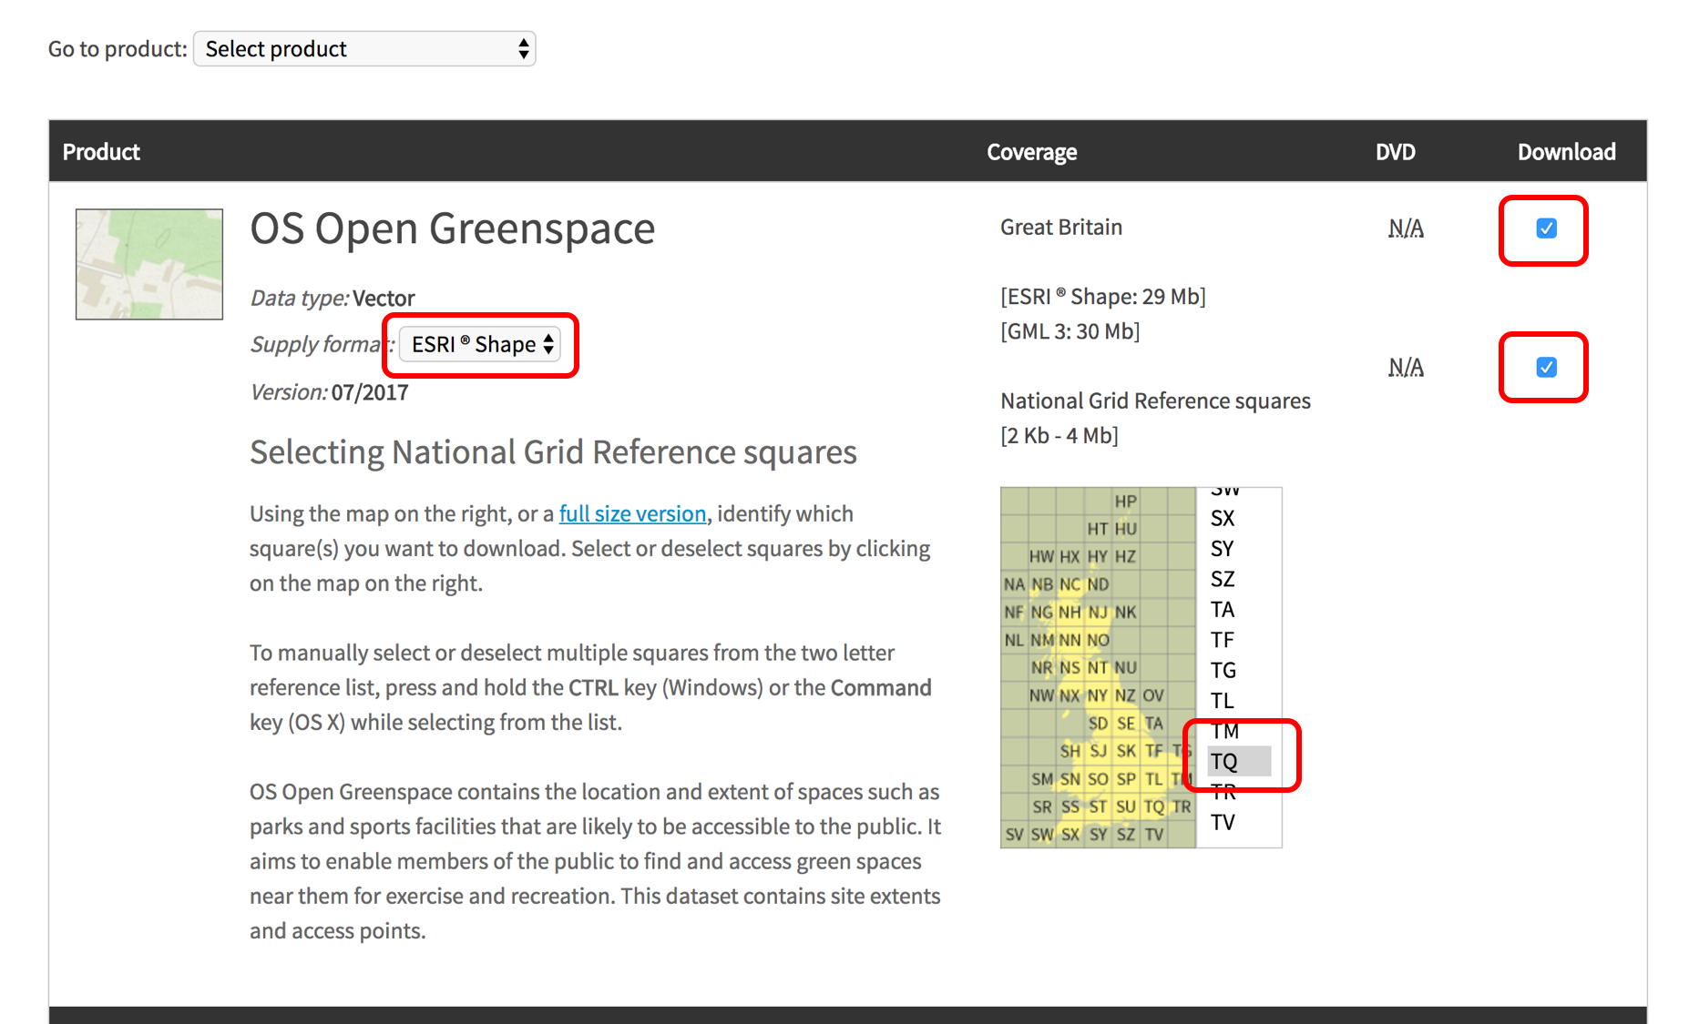

3.1.3 Fill your details and press **Continue.** Check your inbox and click on the **two links** to download the data. Wait for the files to download and move them in your ‘data’ folder.

**3.2 OpenStreetMap Data**

3.2.1 Visit <http://download.geofabrik.de/>

3.2.2 Select **Europe > Great Britain > England > Greater London** , format **[.shp.zip]**

3.2.3 Wait for the file to download. Create a new folder 1_Data_Unzipped and right- click to unzip the file. 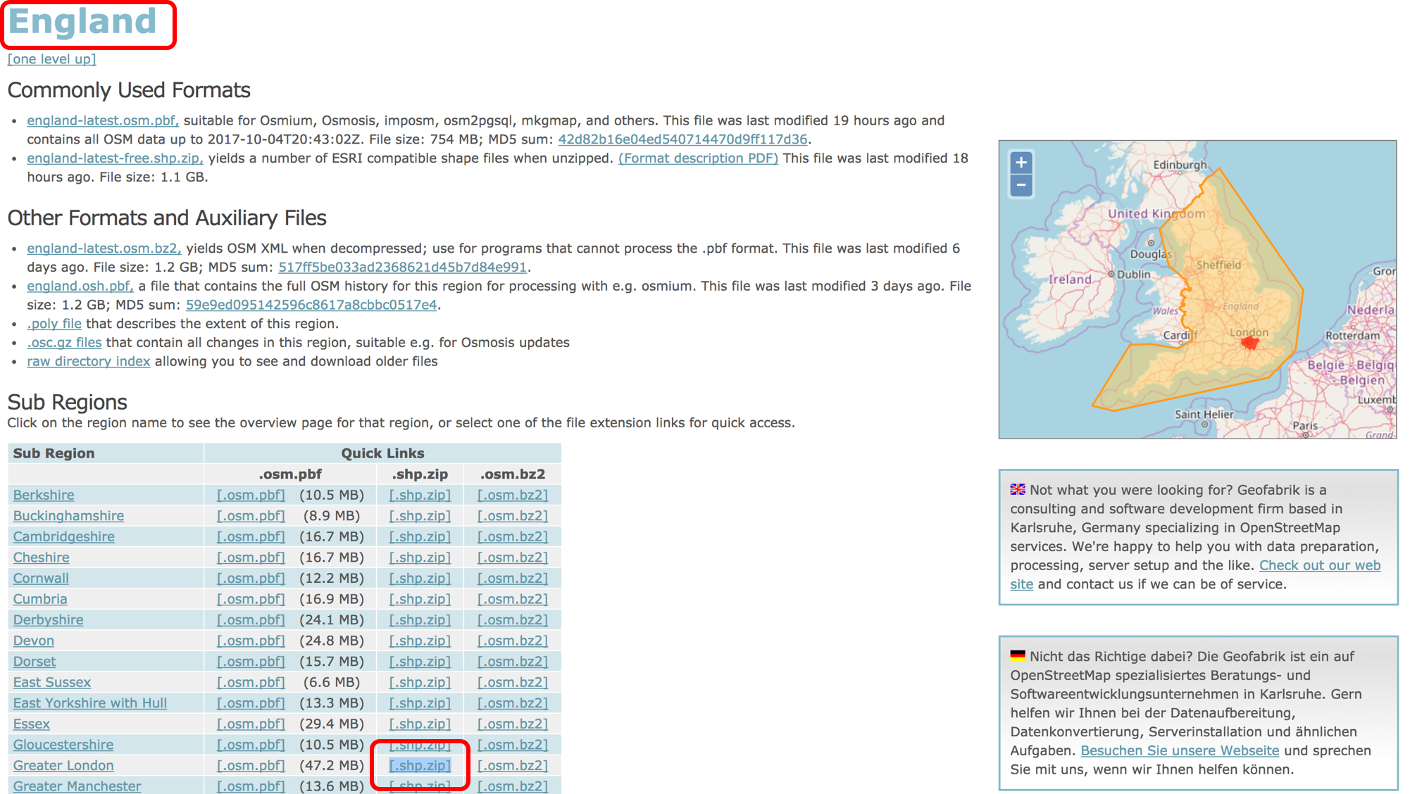

**3.3 Census data**

3.3.1 Visit <https://www.nomisweb.co.uk/>

3.3.2 In the data downloads tab select **Query data > Census 2011 > Key Statistics >** [**KS101EW** - **Usual resident population**](https://www.nomisweb.co.uk/query/construct/summary.asp?mode=construct&version=0&dataset=144)

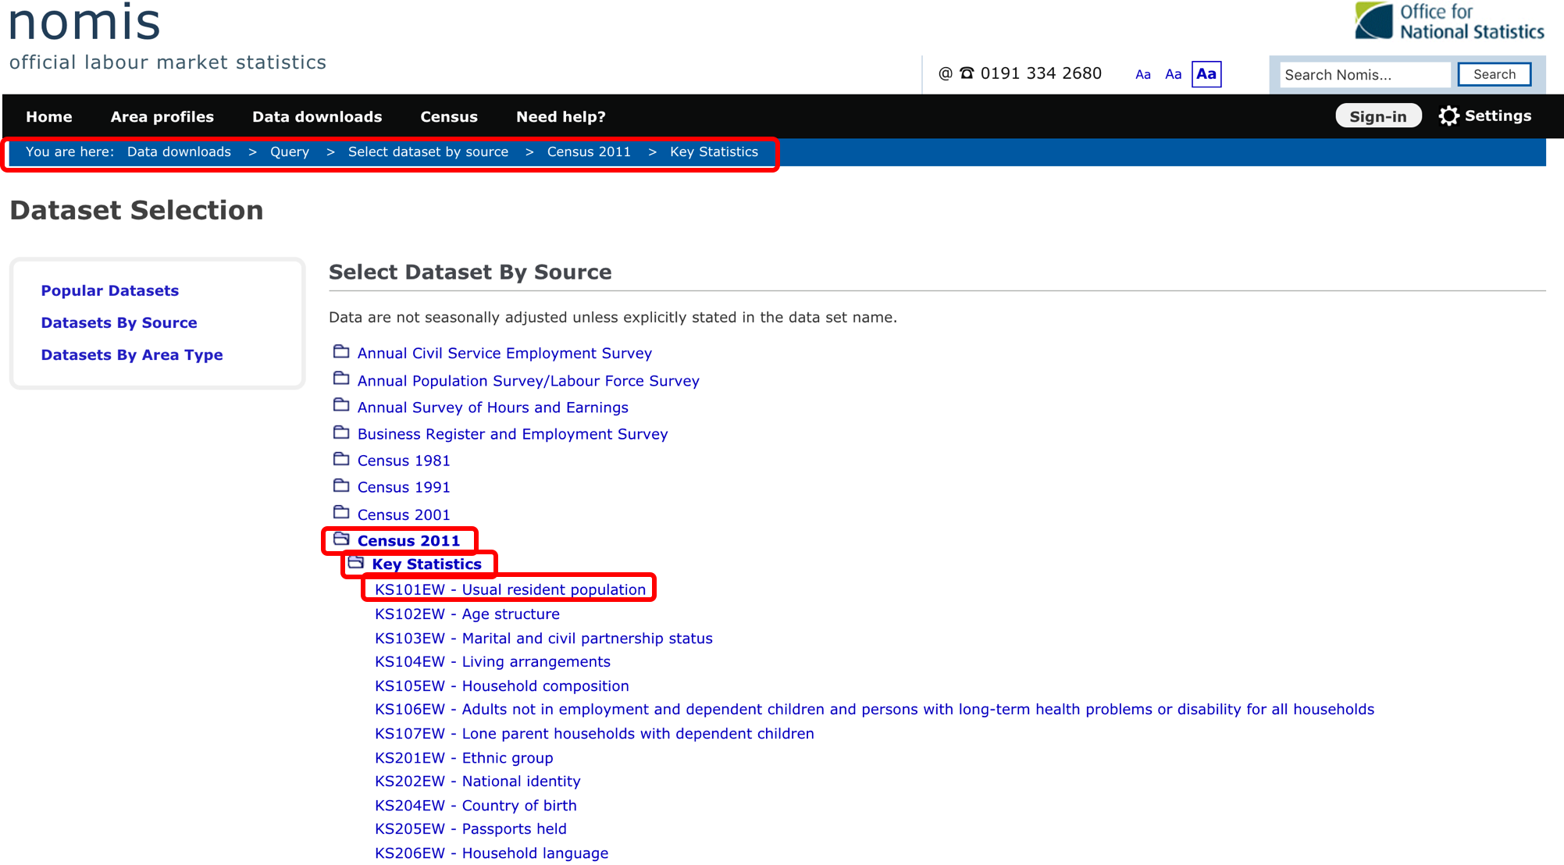

3.3.3 Select **Geography** > **2011 super output areas – lower layer** > **City of London** > **Tick all**

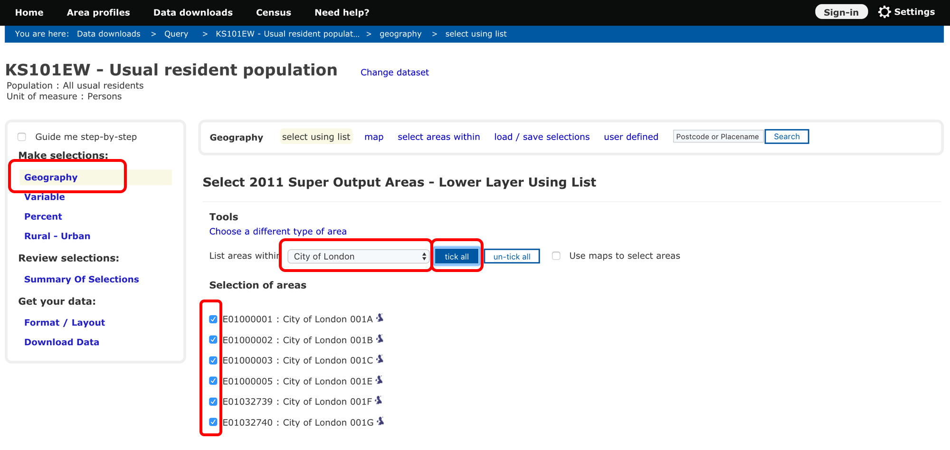

3.3.4 Select **Format/Layout** and tick **Comma Separated values(.csv)**. In Other options tick **Include area codes** and click **Download Data**

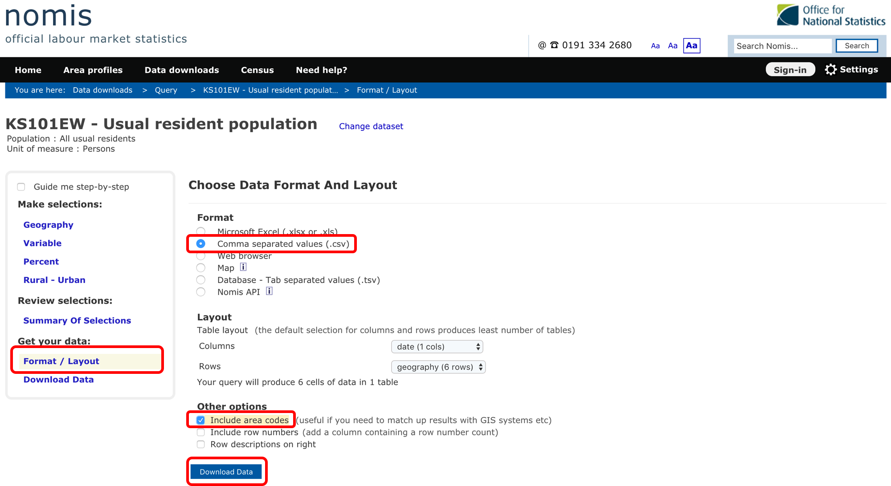

**3.4 Census boundaries**

3.4.1 Visit <https://census.ukdataservice.ac.uk/get-data/boundary-data>

3.4.2 Select **Easy download.** In 2011 boundaries select [**English Lower Layer Super Output Areas 2011**](https://borders.ukdataservice.ac.uk/easy_download_data.html?data=England_lsoa_2011). Select [**Download features in Shapefile format as ZIP file**](https://borders.ukdataservice.ac.uk/ukborders/easy_download/prebuilt/shape/England_lsoa_2011.zip)**.** Unzip the file in 1_Data_Unzipped folder you created before.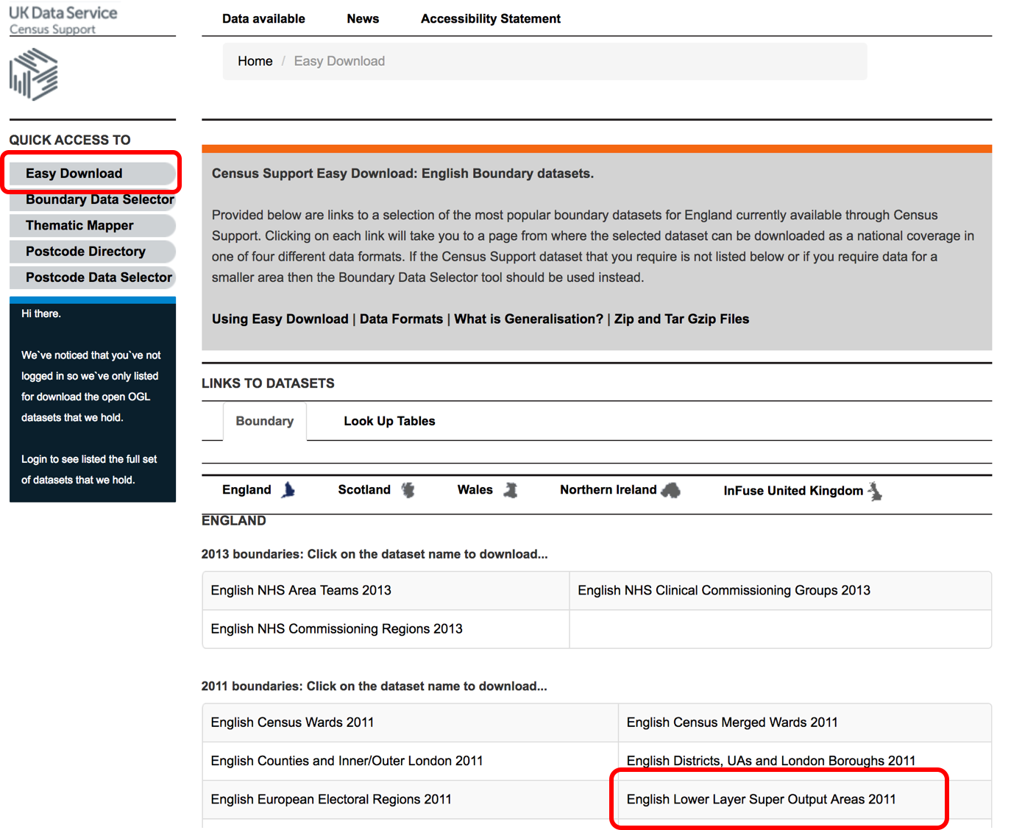

**3.5 Download tfl data**

3.5.1 Visit <https://tfl.gov.uk/info-for/open-data-users/our-open-data?intcmp=3671#on-this-page-7>

3.5.2 Go to section **Network Statistics**. Select **London Underground passenger counts data** and click on [**Counts Entries 2010 Weekday sample data - CSV 101KB**](https://tfl.gov.uk/cdn/static/cms/documents/counts-entries-10-weekday-sample.csv)

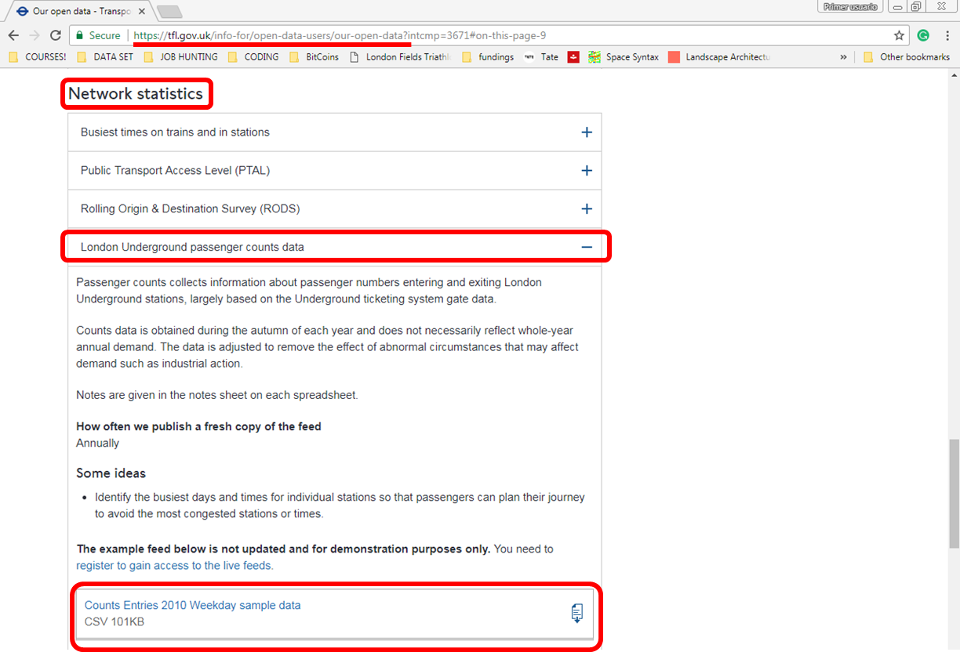

**4. 0 Working with vector layers**

4.0.1 Create a new workspace and add all the street network data **Project** > **New**

4.0.2 Specify the project CRS: Tick **enable on-the-fly CRS transformation** and select **British National Grid EPSG:27700.**

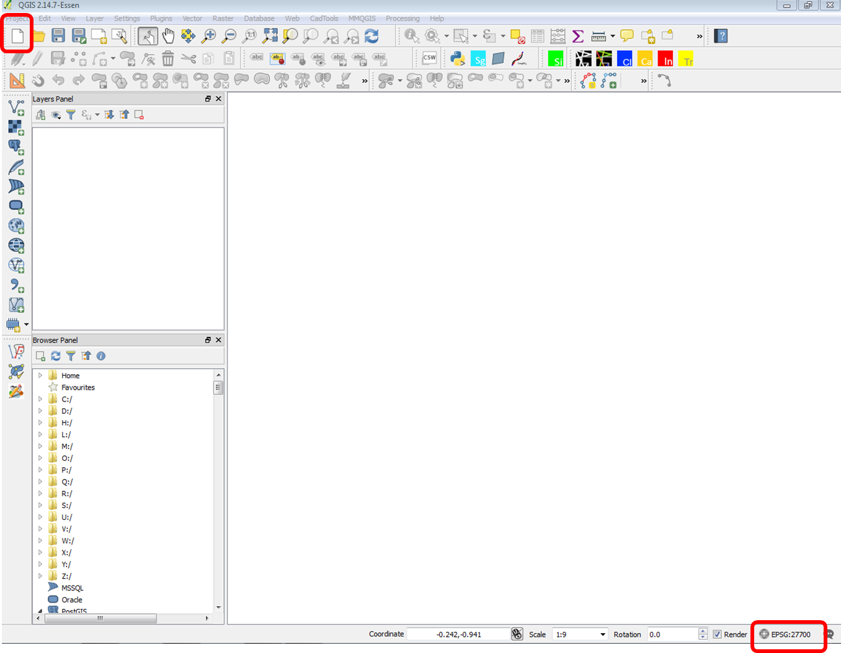

4.0.3 Add group in the layer panel called “RCL maps”

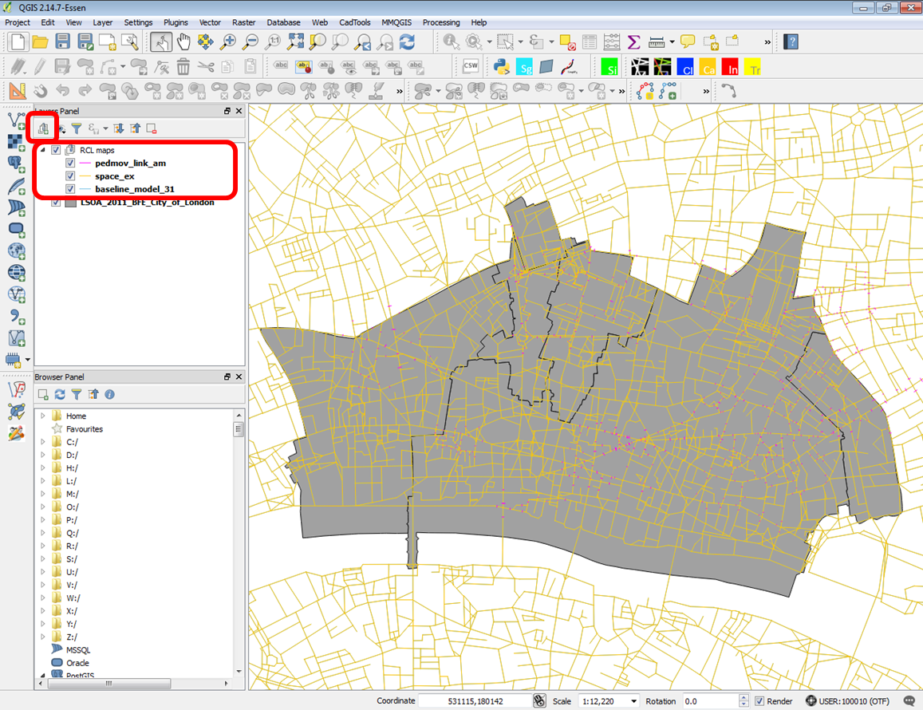

**4.1 Georeferencing a layer**

4.1.1 Add the openstreetmap data that you previously downloaded. Select **Add Vector Layer** > **Navigate** in Data > 1_Data_Unzipped> From the **Fyles of types** list select **ESRI shapefile**. **Open** gis.osm_roads_free_1.shp**.** To add a layer you can also drag and drop the .shp file into your map canvas. Drag the layer to the ‘RCL maps’ group.

**[NOTE]:** a shapefile consists of 4 files (.shp, .prj, dbf, .shx) and renaming just one of them will cause issues. To rename a shapefile you need to rename all 4 files.

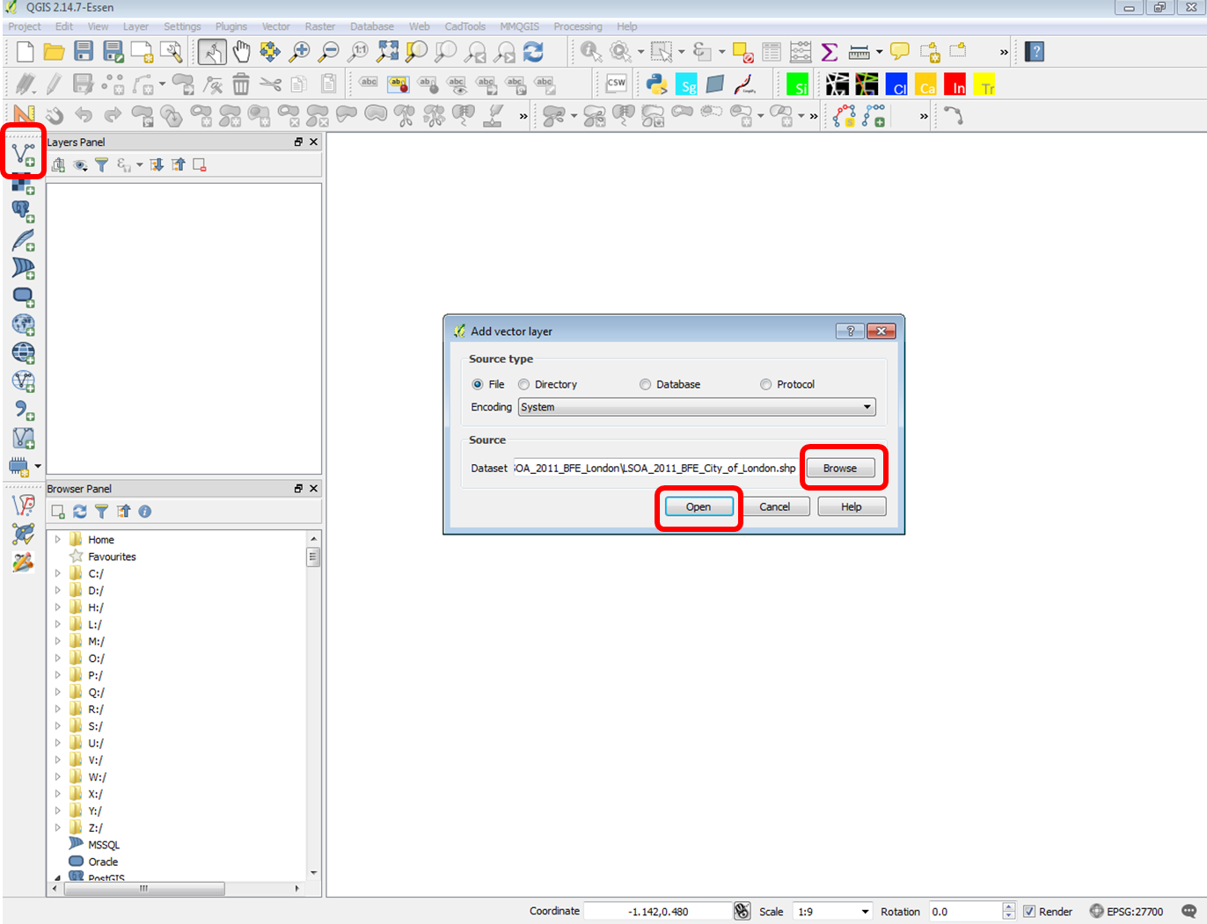

4.1.2 All OpenStreetMap datasets are projected in a world CRS (**WGS 84**) which is a geographic CRS for the whole world. If you look at the map, it looks slightly distorted. We need to reproject our layer to use the project CRS 27700 defined earlier **(EPSG:27700, OSGB 1936/British National Grid)**.

4.1.3 Explore layer properties: right-click on the Layer > **Properties. General** > set Coordinate reference system to **EPSG:4326** > **OK.** This is the file’s native CRS. The layer is re-projected (only visually in your map canvas) according to the project CRS we have defined previously **(EPSG:27700)**.

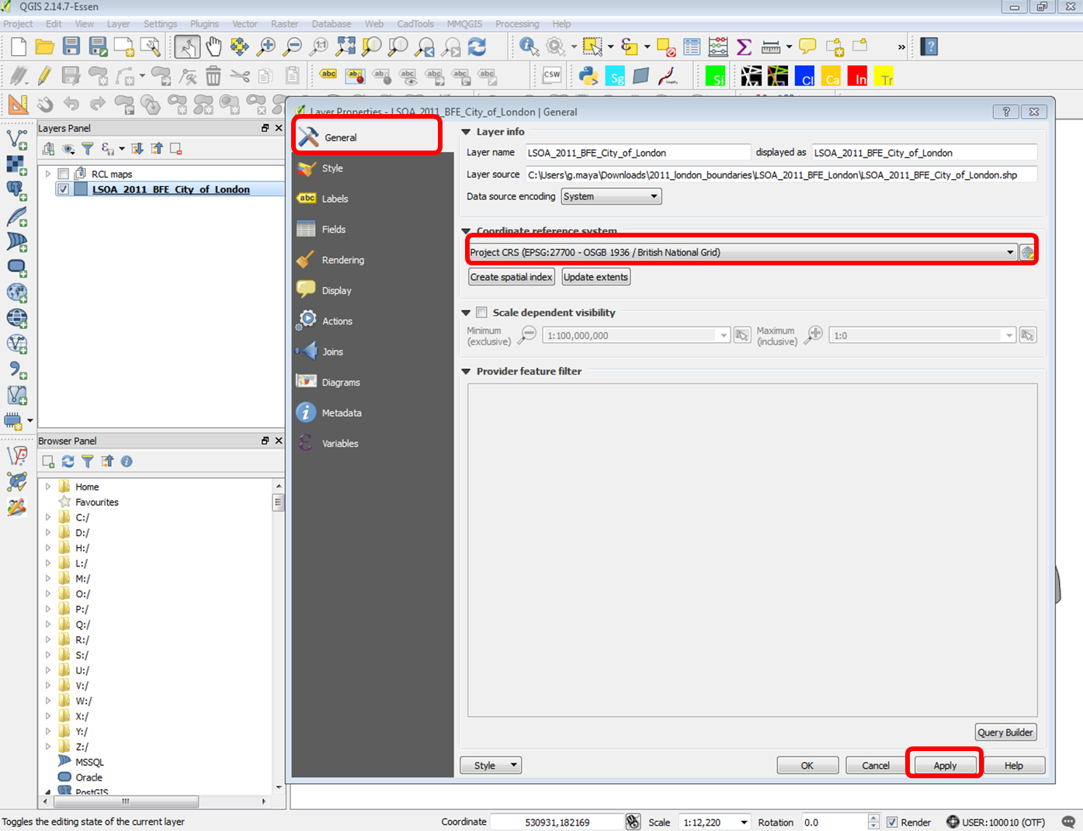

4.1.4 It is recommended that all layers in your workspace are saved with the same CRS. To do that for OpenStreetMap layer right-click **Save layer as** > Format: **ESRI Shapefile** > **Browse** to select the desired location and save as osm_roads_georef > CRS: **Selected CRS (EPSG:27700, OSGB 1936/British National Grid).** Tick **Add saved file to map**. If not in the 'RCL-maps’ layer group, move the layer there. Remove the gis.osm_roads_free_1 layer from your map canvas.

**4.2 Exploring the attributes of layer’s features**

4.2.1 Exploring the attributes table: Select the Layer osm_roads_georef > **Open Attribute Table.**

Select one random row and then go to the main qgis window and select **zoom to selection**. Then press **Deselect Features from All Layers**. Select the info tool and check the feature’ s attribute.

4.2.2 Now select one feature on the map and look at the table. Select **Move selection to Top** to bring the rows with the attributes of the selected features on top of the attribute table.

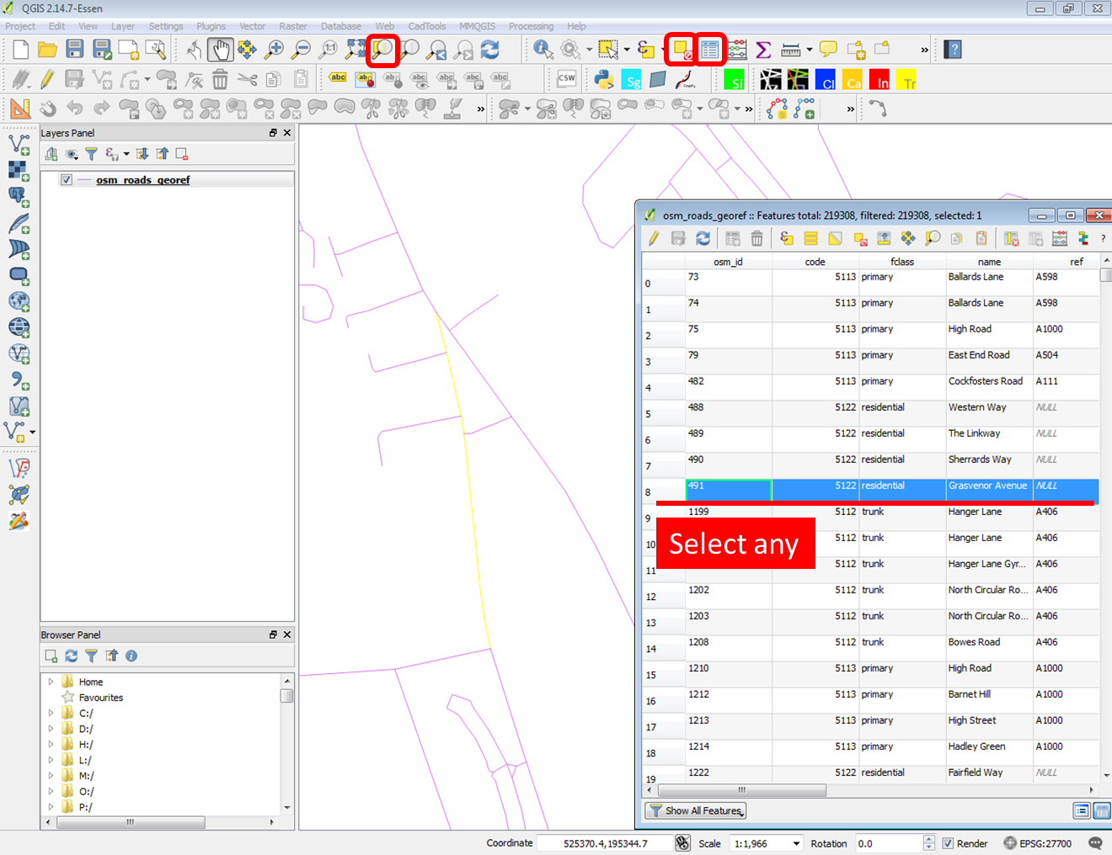

**4.3 Working with plugins**

4.3.1 Select **Plugins**> **Manage and install plugins..** Search for **OpenLayers**. Select **OpenLayers Plugin** and click **Install plugin.** Tick the tickboxnext to the plugin name to load the plugin in your QGIS.

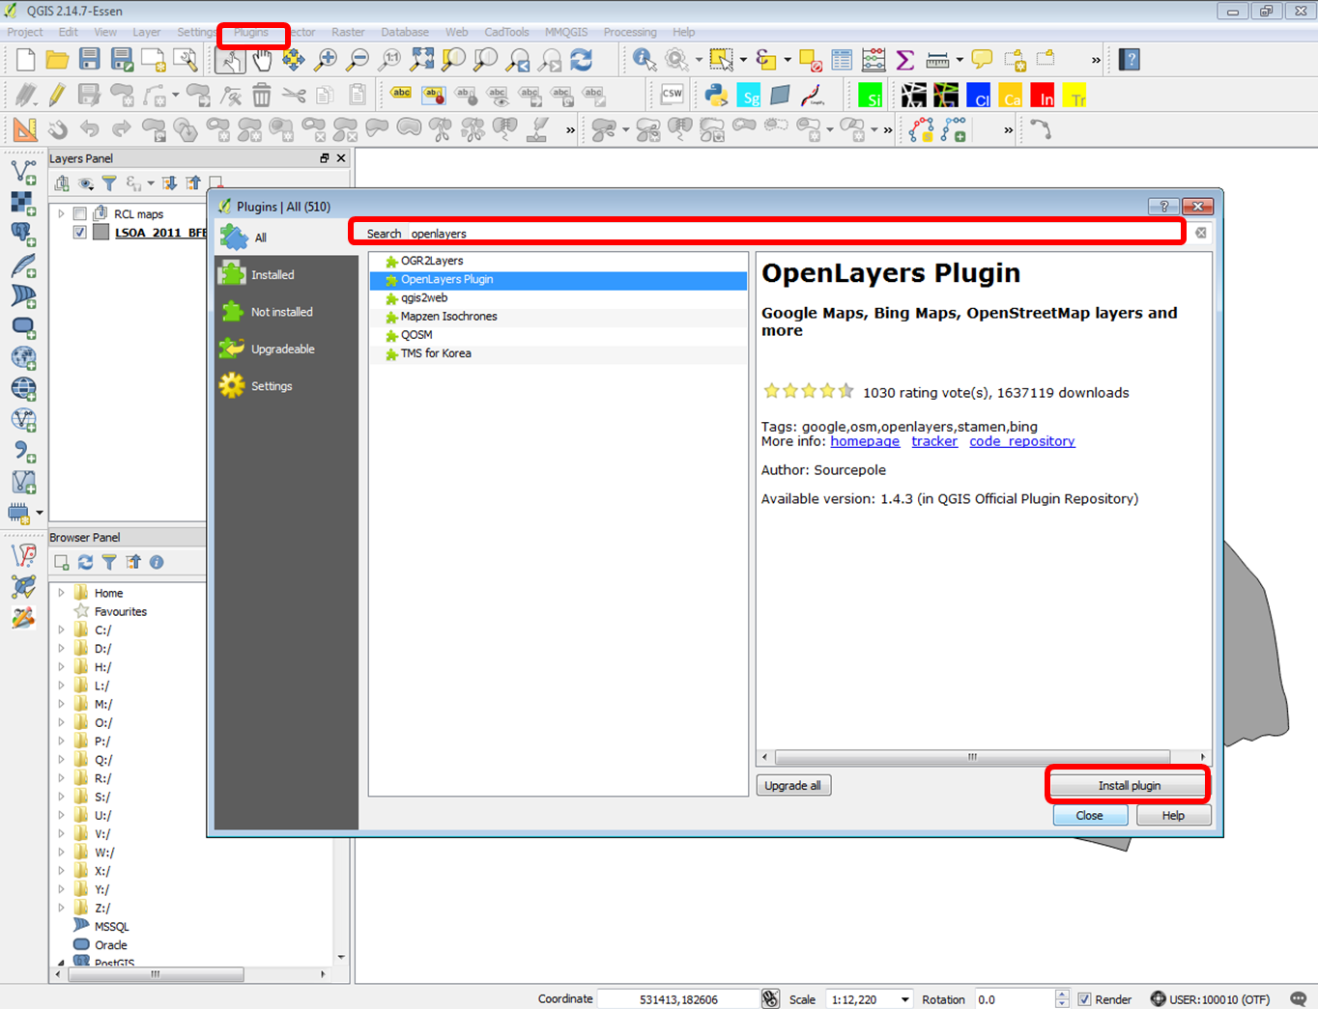

4.3.2 Select **Web**> **OpenLayers plugin** > **OpenStreetMap** > **OpenStreetMap**. Check how your project CRS changes, as it attempts to adjust between different layers CRS. There is no way and you do not need to change the projection of OpenStreeMap raster layer. If you remove the layer, you can change the project CRS.

4.3.3 **Add group** in the layer panel called ‘basemaps” and move it to the end of your layer panels. Move the OpenStreetMap layer there.

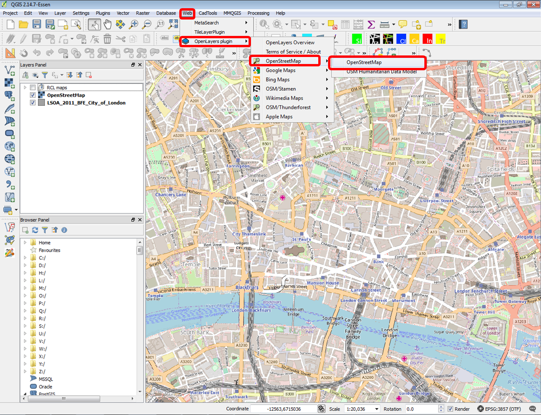

**4.4 Selecting features**

4.4.1 Select **Add Vector Layer** > **Browse** into your local library > Navigate to folder oproad_essh_gb > data > TQ_RoadLink.shp

4.4.2 With the **Select Features by radius** tool select features from the map canvas to a similar extent as the openstreetmap layer. Right-click layer > **Save as..** Specify name os_roads_london, format ESRI Shapefile, CRS: **Selected CRS (EPSG:27700, OSGB 1936/British National Grid)** andtick **Save only selected features** and **Add saved file to map.** Remove the TQ_RoadLink layer from your map canvas.

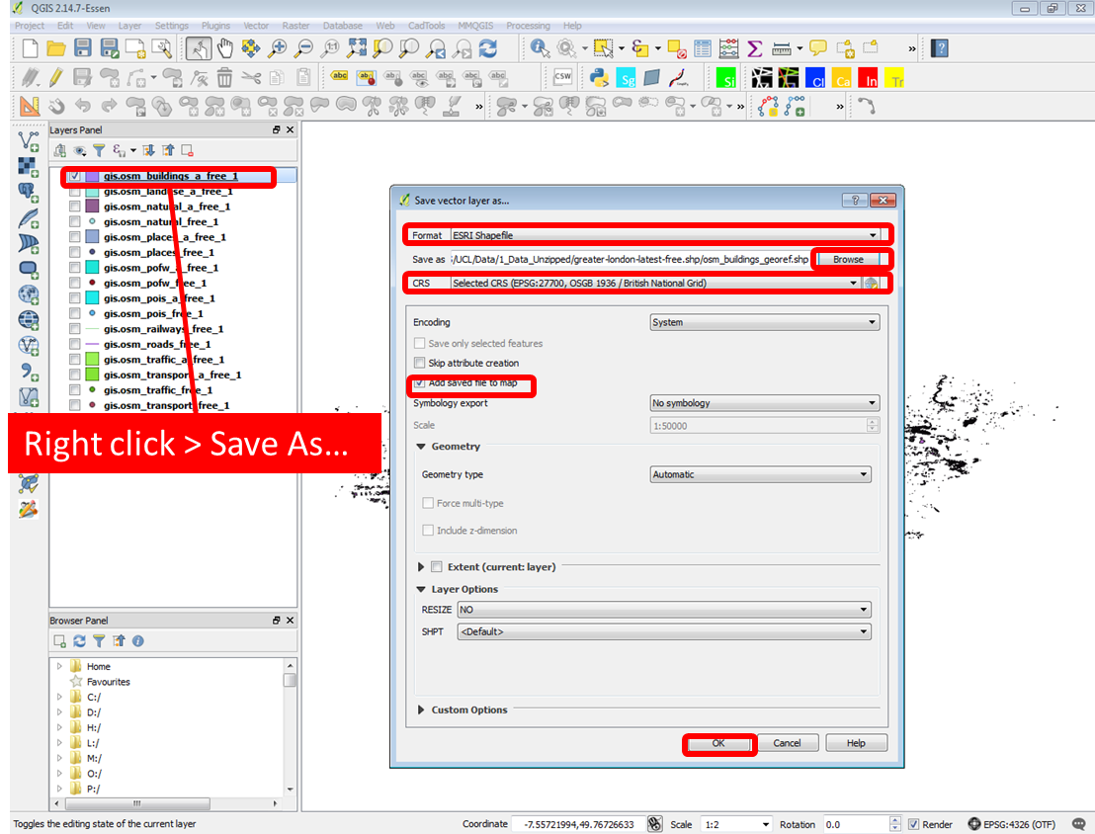

**4.5 Visualising features’ attributes**

4.5.1 There are ways to visualise the data that is held in the attribute table. Right-click on layer and Open attribute table. Look at column (field) ‘fclass’. We are going to visualise the categories that the field ‘fclass’ consists of. Right-click on the layer and select **Properties**. Select **Style** specify **Categorised** and select column **fclass**, colour ramp **Random colours** and click **classify**. Click **OK**.

4.5.2 Select to visualise the field (column) ‘class’ of os_roads_london layer and compare with OpenStreetMap fclass column. Right-click on the layer and select **Properties**. Select Style **Categorised**, column **class**, colour ramp **Random colours** and click **classify**. Click **OK**. Then repeat for column **formOfWay.**

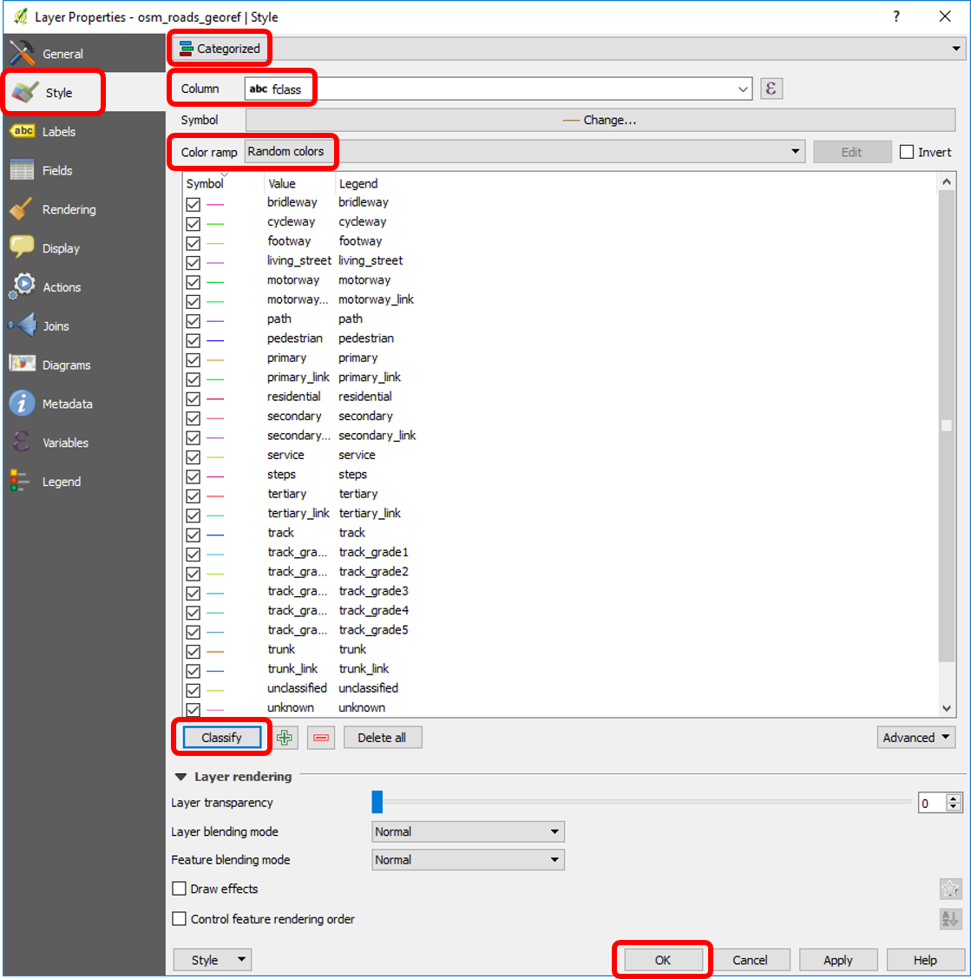

**4.6. Editing the layer data - geometry**

4.6.1 Select the layer os_roads_london to edit. Click on **toggle editing** and try adding, modifying or deleting a feature. Add a feature of a street that is missing from the map. Modify a feature to match exactly the RCL (Road-centre-line). Delete a feature that is not a street in your basemap. Click Toggle editing to save changes.

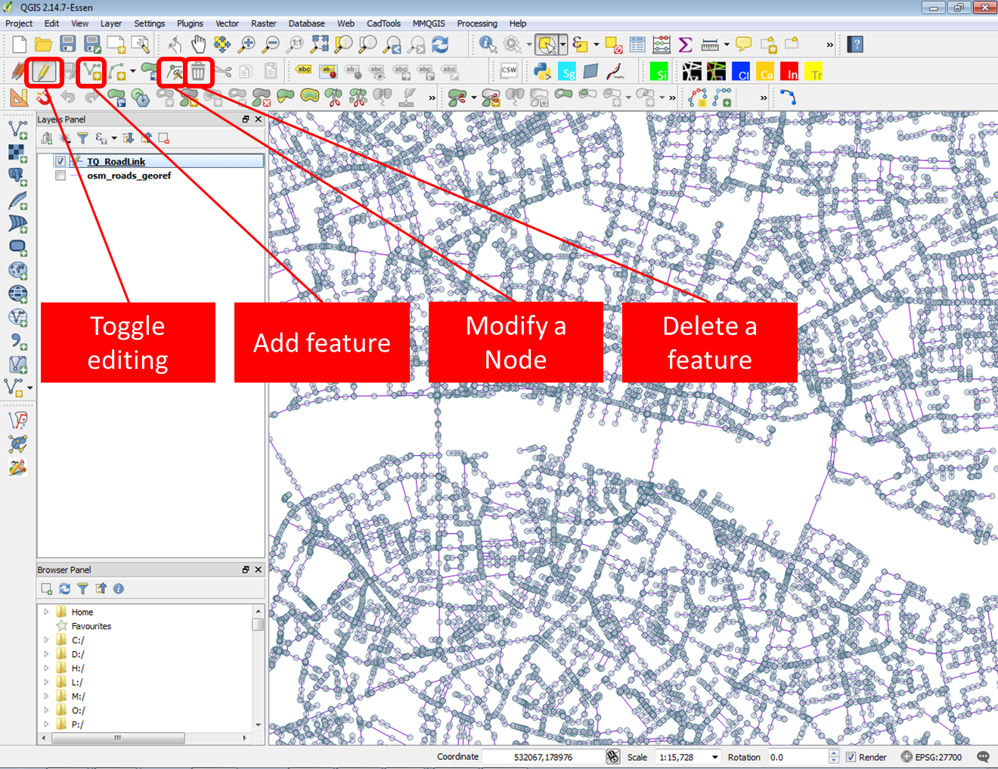

**4.7. Creating a new layer and inserting features**

4.7.1 Add group in the layer panel called “transport”

4.7.2 Create new vector layer **Layer** > **Create layer** > **New shapefile Layer**

Specify name ‘stations_col’, select Point layer, CRS: **Selected CRS (EPSG:27700, OSGB 1936/British National Grid)** and press OK.

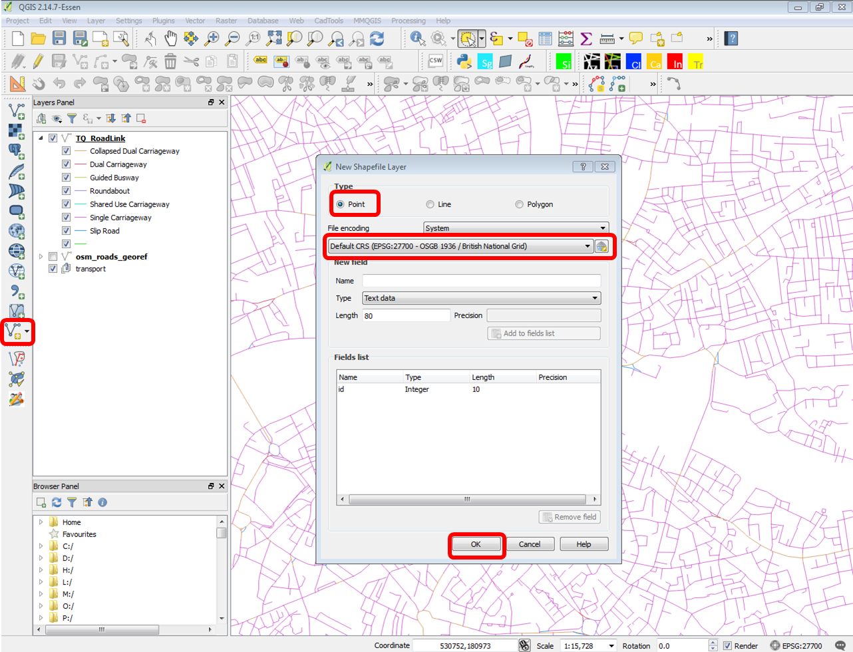

4.7.3 Select the layer to edit > **Toggle editing.** Add the stations as points on the map as shown below.

Click **Toggle editing** to save your changes.

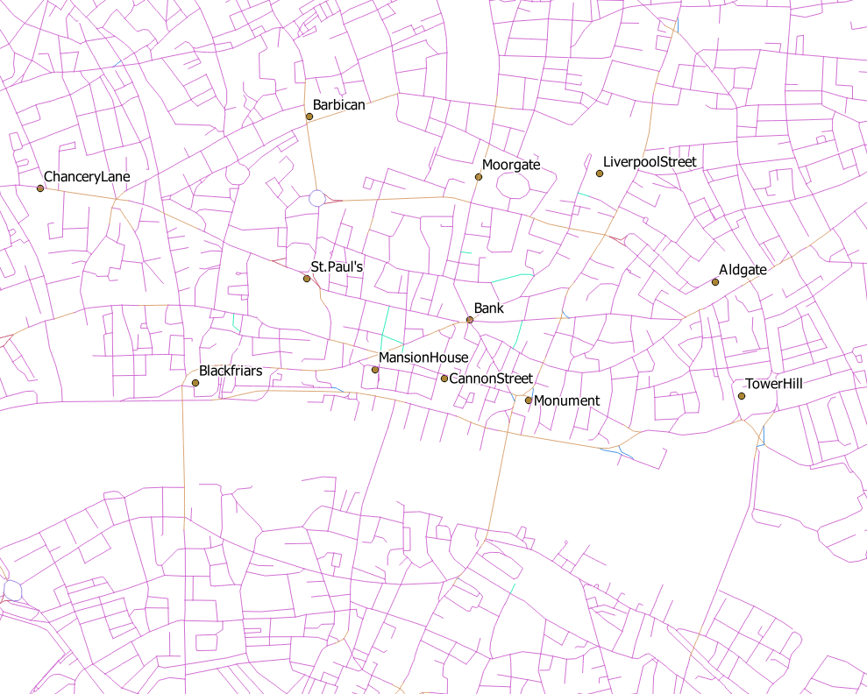

**4.8 Editing the layer data - attributes**

4.8.1 Select the layer to edit > **Toggle editing.** Right-click > L**ayer properties** > **Fields > Add Field** with name **‘name’**, type **text** and length **20**.

Right-click > Open **Attribute table**. Set this windows aside and update each point data with the name of the stations as shown in the image in 4.3.6. Save the changes > **Toggle editing.**

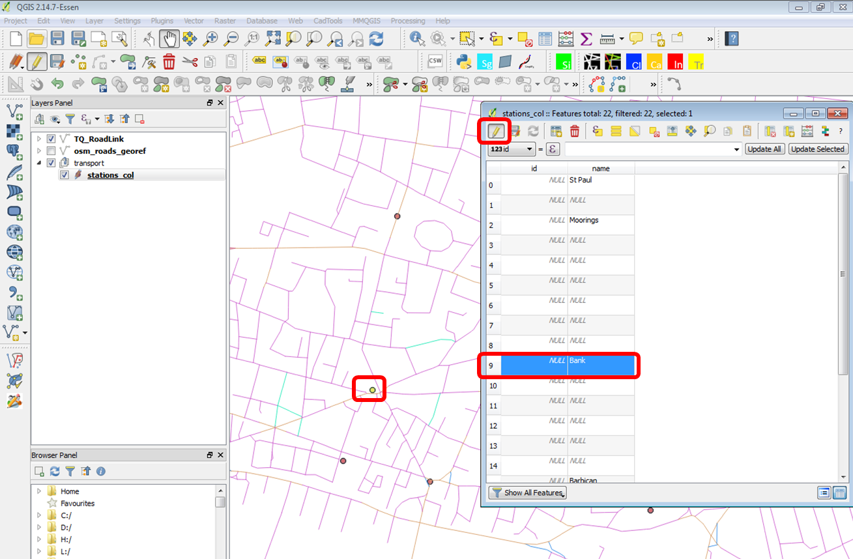

4.8.2 Right-click on the layer and go to **Labels**. Labels visualise the selected attributes of features in the map canvas. Select **Show labels for this layer**. Select **Label with** ‘name’. You may want to adjust text and placement options.

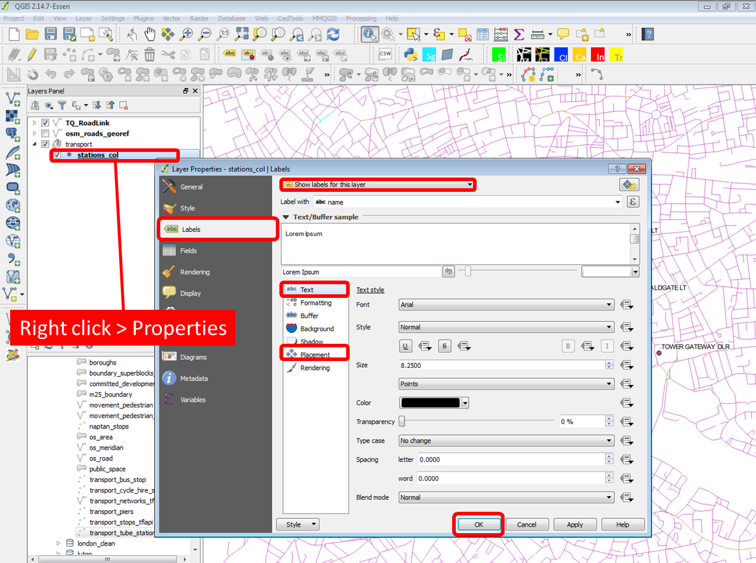

**4.9 Using the field calculator**

4.9.1 Select **Add Vector Layer** > **Browse** into your local library > Navigate to opgrsp_essh_tq> OS Open Greenspace (ESRI Shape File) TQ> data> Select **TQ_GreenspaceSite.shp** to import the open spaces data. Make a new group layer called ‘Green spaces’ and move the imported layer into this group.

4.9.2. Right-click > Open **Attribute table**. Click on **toggle editing** and select **Add field.** Type ‘perimeter’ for name , select **Decimal number (real)** for Type, type **4** for Length and **2** for Precision. Click **OK**.

4.9.3 Open the **Field Calculator** > Tick Update Existing field > Select the field ‘perimeter’ you just created. Type **$perimeter** and press **OK.**

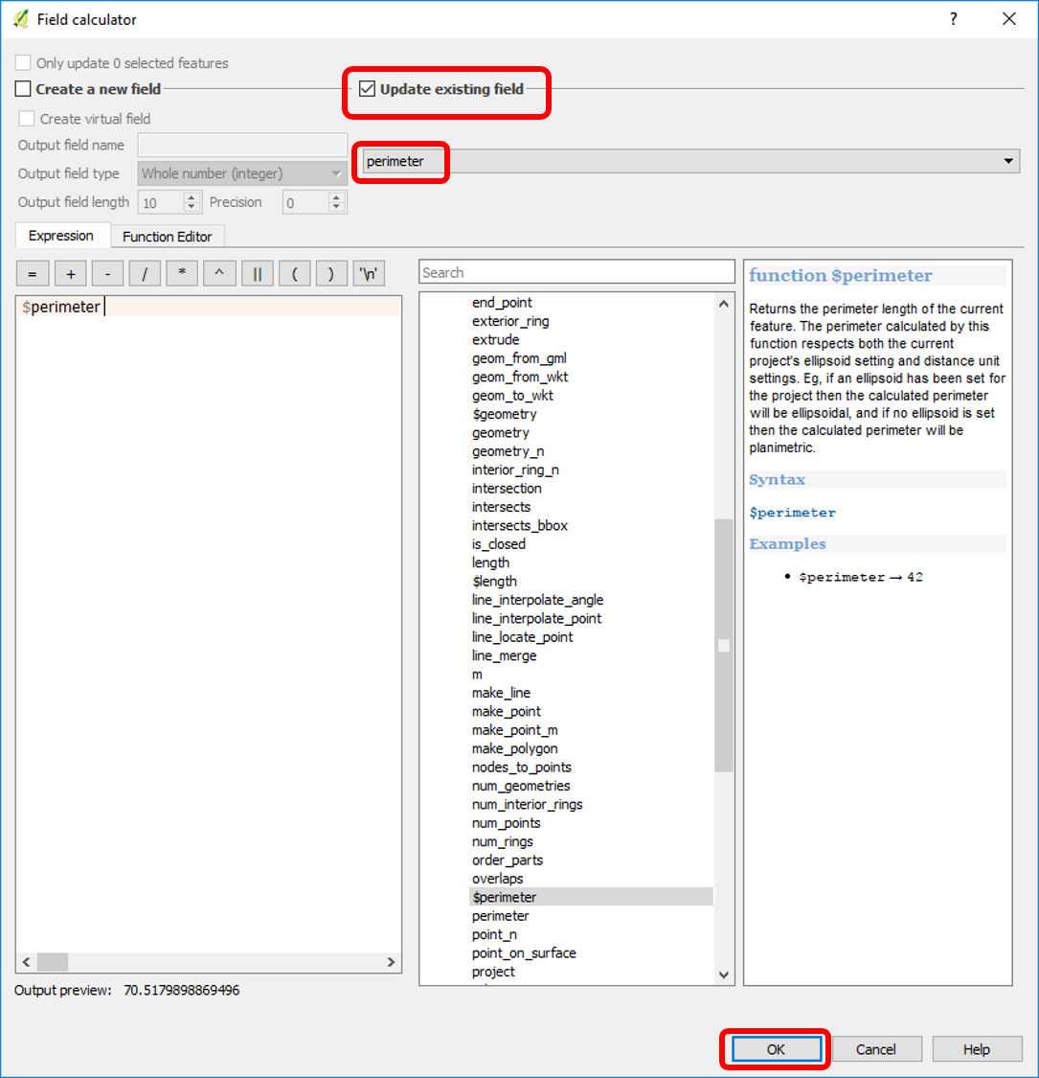

4.9.4 Click on **toggle editing** to save the changes and right-click to **Open Attribute table** to view the results.

4.9.5 Right-click on the layer and select **Properties**. Select Style **Graduated**, column **perimeter**, method **Color**, color ramp **Greens**. Select mode **Equal Interval**, classes **5** and click **classify** and **OK**.

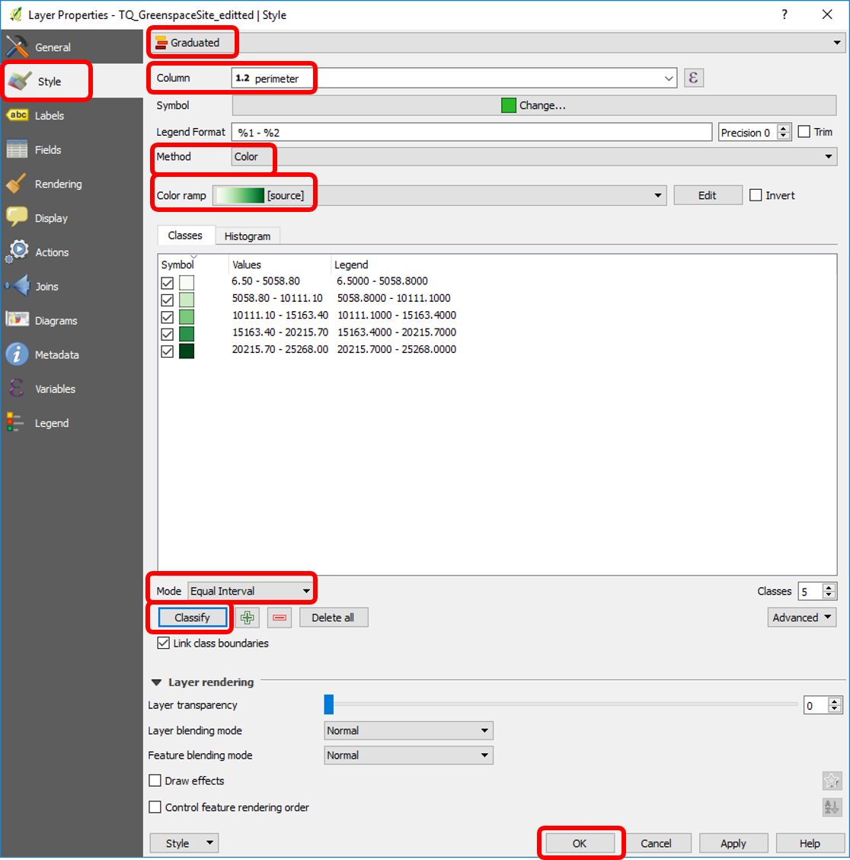

**4.10 Exchange spatial information between layers**

4.10.1 Select **Add Vector Layer** > **Browse** into your local drive > **Open** Navigate to opgrsp_essh_tq> OS Open Greenspace (ESRI Shape File) TQ> data> Select **TQ_AccessPoint.shp** to import the access points data.

4.10.2 Right-click on layer > **Open Attribute Table> Fields> Toggle editing> Add field**

Type ‘n_access_p’ for name and select **Whole number(integer)** for the Type.

4.10.3 Update the attribute ‘n_access_p’ with the number of access points per green space polygon. Do this process for green spaces in area of the the city of London. To do this select one green space polygon on your map then click **Open** **attribute table**, click **Move selection to top** and type the number of access points in the ‘n_access_p’ column. Continue with the next polygon feature.

4.10.4 Right-click on the layer and select **Properties**. Select Style **Graduated**, column ‘n_access_p’, method **Colour**, Colour ramp **YlGn**. Select mode **Pretty breaks**, classes **7** and click **classify** and **OK**.

**4.11 Working with census data**

4.11.1 Make a new group layer called ‘Census’ and add vector layer > Select **england_lsoa_2011.shp**

4.11.2 Click on **Select by expression** and type left("name" ,14) = 'City of London' and press Select. Right-click on layer > **Save as**. Browse the location to save the file and save it as ‘lsoa_col’. Make sure you tick **Save only selected Features.** Save as lsoa_col.shp and tick **Add Layer to the map**.

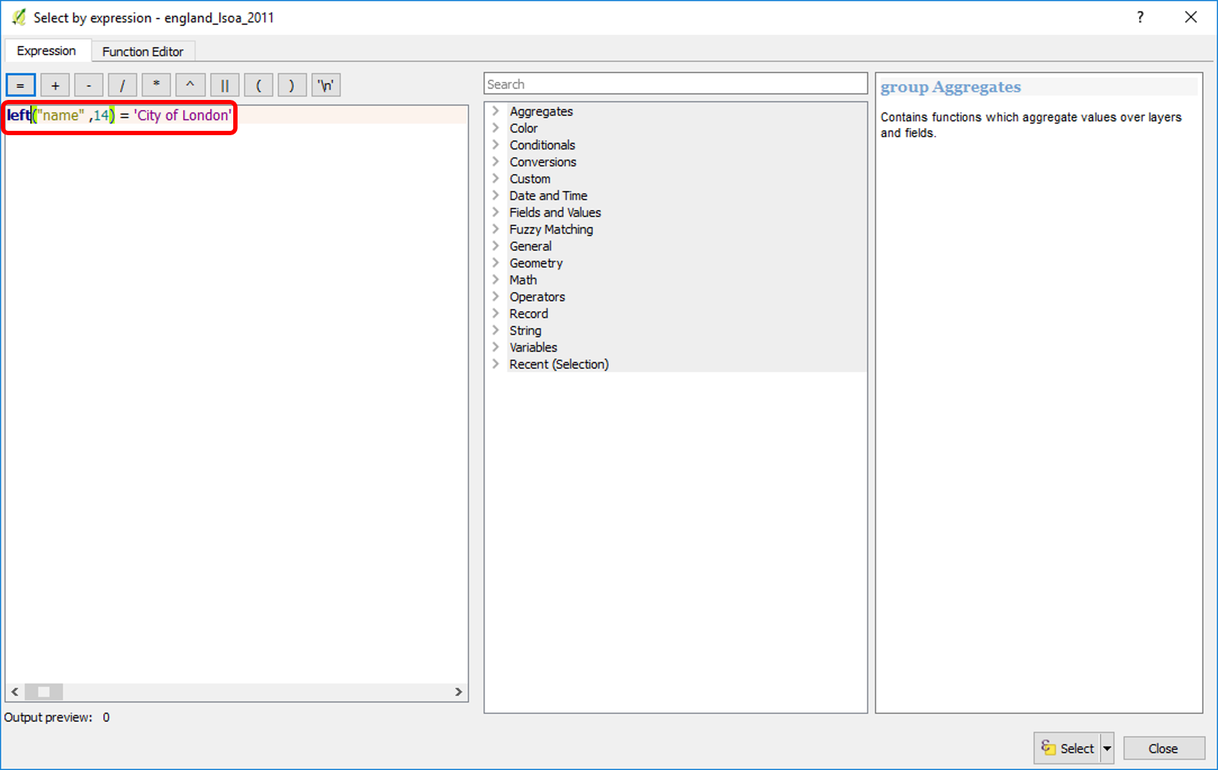

4.11.3 Open Excel and open the excel file you downloaded from nomisweb in 3.3. Modify the excel file to look like below. Save it as a new file with the name lsoa_pop in Comma-Separated format.

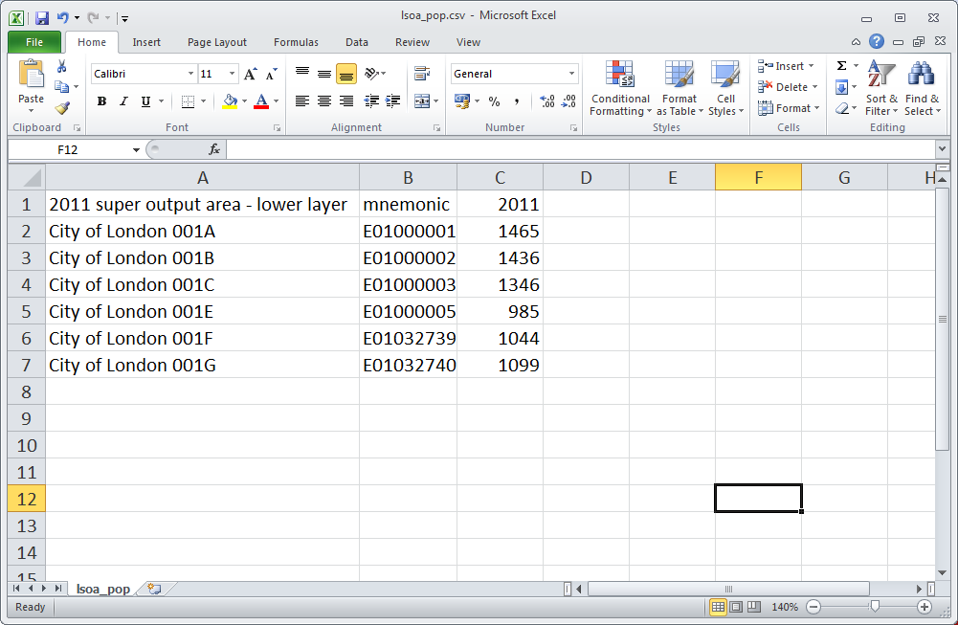

4.11.4 Select **Add Delimited Text Layer** > Browse the file lsoa_pop.csv. Select file format **CSV**. In geometry definition select **No geometry**. Right-click > **Open Attribute table.**

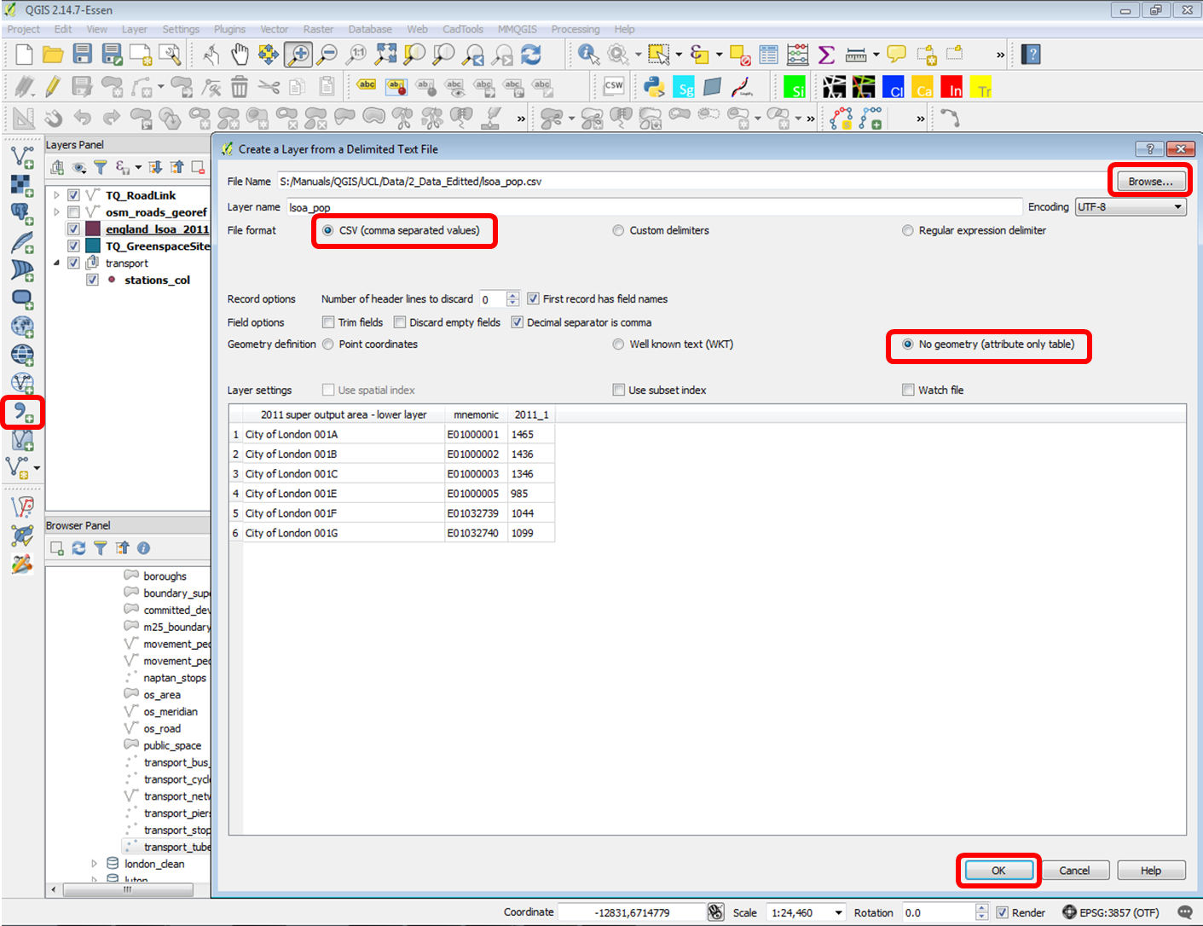

**4.12 Working with transport data**

4.12.1 Open Excel and open the csv file you downloaded from tfl in 3.5. This data shows passenger usage per station. Edit the file in excel; remove the last row showing total values, create a new column after column Station , name it ‘Station_name’ and update the column with the formula : **=SUBSTITUTE(B2, " ", "").** Save the file as passenger_count.csv. Close excel. Select **Add Delimited Text Layer** > Browse the file passenger_count.csv. Select file format **CSV**. In geometry definition select **No geometry**.

**4.13 Attribute join**

4.13.1 In the stations_col file we have stations Bank and Monument as two points. However in the transport usage data Bank and Monument is recorded as one station with the name ‘Bank&Monument’. We need to make sure that the data is synchronised before we attempt any join. Delete one of the two points of the stations, move the other between the two stations and change the name of the station to ‘Bank&Monument’ as shown below.

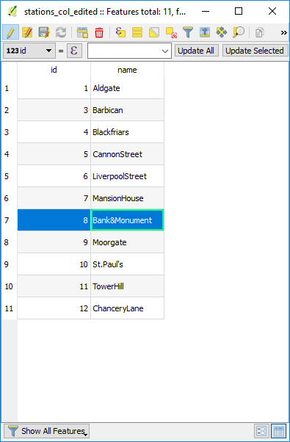

4.13.2 Double click to open the **layer properties** of lsoa_col.shp. Select **Joins** > Select the **+** button. specify **Join layer** lsoa_pop, **Join field** mnemonic and **Target field** code. Right-click > **Open Attribute table** to view the join. Notice that the new columns added are virtual and are not saved in the shapefile. The joins are saved with the workspace. Try removing the lsoa_pop layer and notice how the join disappear. Restore the join.

You can save the joined file as a new file if you wish. In this way the joined data will be saved with the shapefile data.

**4.14 Making calculations**

4.14.1 Open the **Field** **Calculator** > Select **Create a new field** > Specify Output field name: ‘popdensity’ and **Output field type: Decimal number (real)** select **Precision 3**. In the expression, type  **"lsoa_pop_2011_1" / $area**  to get the density of population per square meter. Click **OK**

**Open Attribute table** to view the results.

4.14.3 Right-click on the layer and select **Properties**. Select Style **Graduated**, column **‘popdensity’**, method **Colour**, Colour ramp **Greys**. Select mode **Equal Interval**, classes **8** and click **classify** and **OK**.

4.14.4 Double click to open the layer properties of stations_col.shp. Select **Joins** > Select the **+** button

Specify Join layer as passenger_count, **Join field** as Station_name and Target field as name. Tick **Custom field name prefix** and leave it blank. **Open Attribute table** to view the results.

4.14.6 Right-click on the layer and select **Properties**. Select Style **Graduated**, column **Total**, method **Color**  and Color Ramp **Greys**. Select mode **Equal Interval**, classes **4** and click **classify** and **OK**.

**4.15 Exporting a raster map image**

4.15.1 **Project > Composer Manager >** then **Add** a new print composer**.** Type a name. The print composer will be saved under this name together with the workspace.

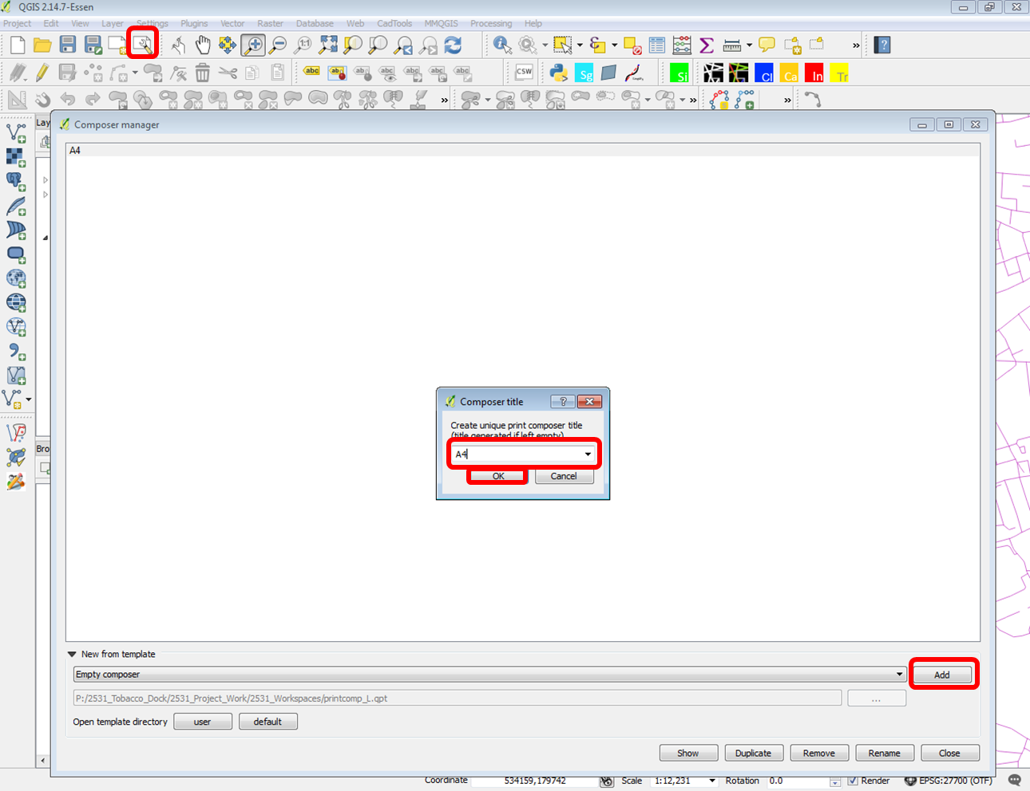

4.15.2 Export an image showing the population density of lsoa boundaries, tube stations with total passenger counts and green spaces with the number of access points: Select **add map** and draw window to add map. **Move item content** , change page setup in **Composition** and scale in **Item properties > Main properties i**f necessary. Select **Export image**.

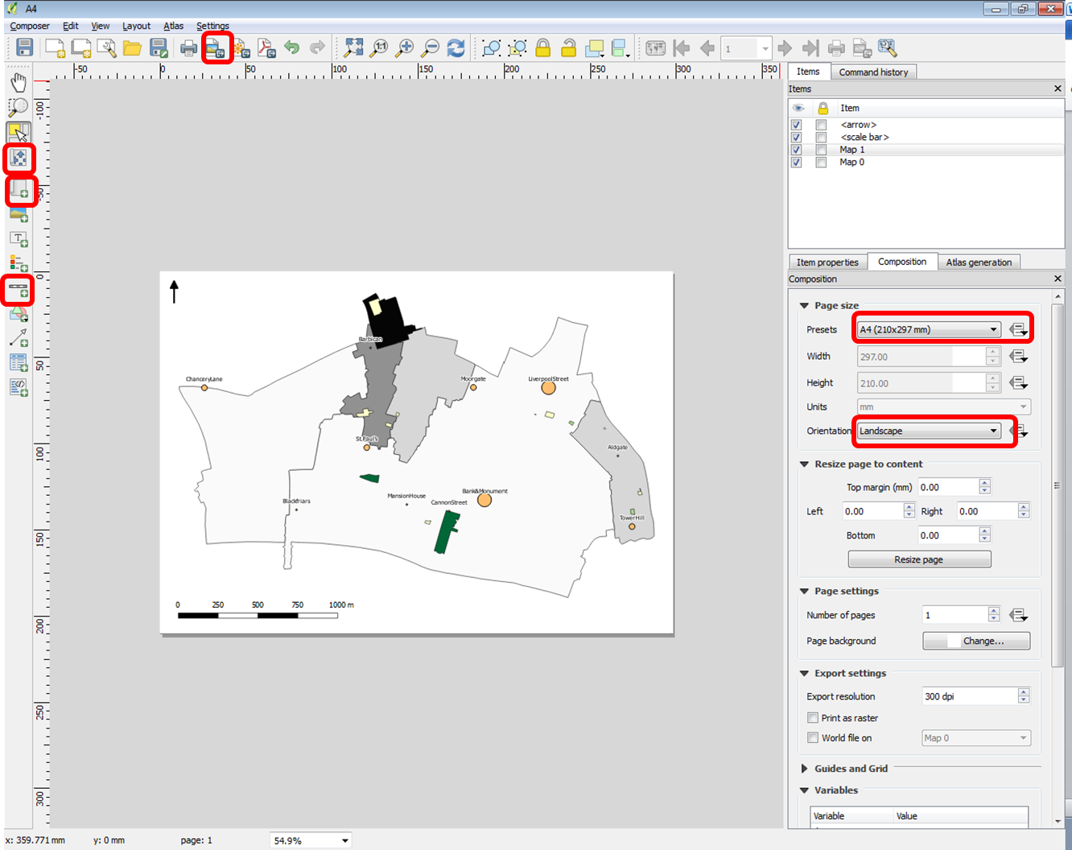

**References**

**Data Sources**

World

<http://download.geofabrik.de/>

[https://www.openstreetmap.org/#map=13/51.5306/-0.0395](https://www.openstreetmap.org/)

UK

<https://www.ordnancesurvey.co.uk/opendatadownload/products.html>

<https://www.nomisweb.co.uk/>

<https://www.dft.gov.uk/traffic-counts/download.php>

<https://data.gov.uk/>

<https://www.ukdataservice.ac.uk>

<https://data.london.gov.uk/>

<https://tfl.gov.uk/info-for/open-data-users/our-open-data?intcmp=3671>

**Further training & reading**

<http://docs.qgis.org/2.14/en/docs/gentle_gis_introduction/>

<http://docs.qgis.org/2.14/en/docs/user_manual/>

<http://www.qgistutorials.com/en/> (**recommended sections**: Overview, Quickstart, Basics GIS operations, Intermediate GIS operations)

[http://docs.qgis.org/2.14/en/docs/training_manual/ (**recommended chapters** 1- 12)](http://docs.qgis.org/2.14/en/docs/training_manual/)

**Mapping and visualisation**

<http://www.viewsoftheworld.net>

<https://www.qgis.org/en/site/about/screenshots.html>

**Projection**

<http://www.epsg-registry.org/>

[http://docs.qgis.org/2.0/en/docs/gentle_gis_introduction/coordinate_reference_systems.html#on-the-fly-projection](http://docs.qgis.org/2.0/en/docs/gentle_gis_introduction/coordinate_reference_systems.html)